Capstone Project Automatic Ticket Assignment Interim Report

Table of Contents
Summary of problem statement, data and findings 2
Understanding the Business 2
Objective 2
Observations from the given Dataset 2
Observations from Target Class 3
Summary of the Approach to EDA and Pre-processing 4
Data Pre-processing 4
Data Pre-processing – Addressing skew of target class 4
Data cleaning 5
Word Distribution 6
Lemmatization & Stop words removal 7
Spell Check 7
Deciding Models and Model Building 7
Modelling 7
Traditional ML Models 7
Observation from the results of the traditional models 8
Model Clustering 9
Analysis using WordCloud 9
Model evaluation 11
Comparison to benchmark 11
How to improve your model performance? 12
Implications 12
Limitations 12
Suggestions for future model improvement 12

Summary of problem statement, data and findings

Understanding the Business

In any IT industry, Incident Management plays an important role in delivering quality support to customers. An incident ticket is created by various groups of people within the organization to resolve an issue as quickly as possible based on its severity. Whenever an incident is created, it reaches the Service desk team and then it gets assigned to the respective teams to work on the incident.
The Service Desk team (L1/L2) will perform basic analysis on the user's requirement, identify the issue based on given descriptions and assign it to the respective teams.
The manual assignment of these incidents might have below disadvantages:
  - More resource usage and expenses
  - Human errors - incidents get assigned to the wrong assignment groups
  - Delay in assigning the tickets
  - More resolution times
  - If a particular ticket takes more time in analysis, other productive tasks get affected for the service desk

If this ticket assignment is automated, it can lower resolution time and be more cost-effective, enabling the service desk team to focus on other productive tasks.

Objective

From the given problem description, we could see that the existing system is able to assign 75% of the tickets correctly. Hence, our objective here is to build an AI-based classifier model to assign the tickets to right functional groups by analysing the given description with an accuracy of at least 85%.

Observations from the given Dataset
The data consists of four columns as given below.
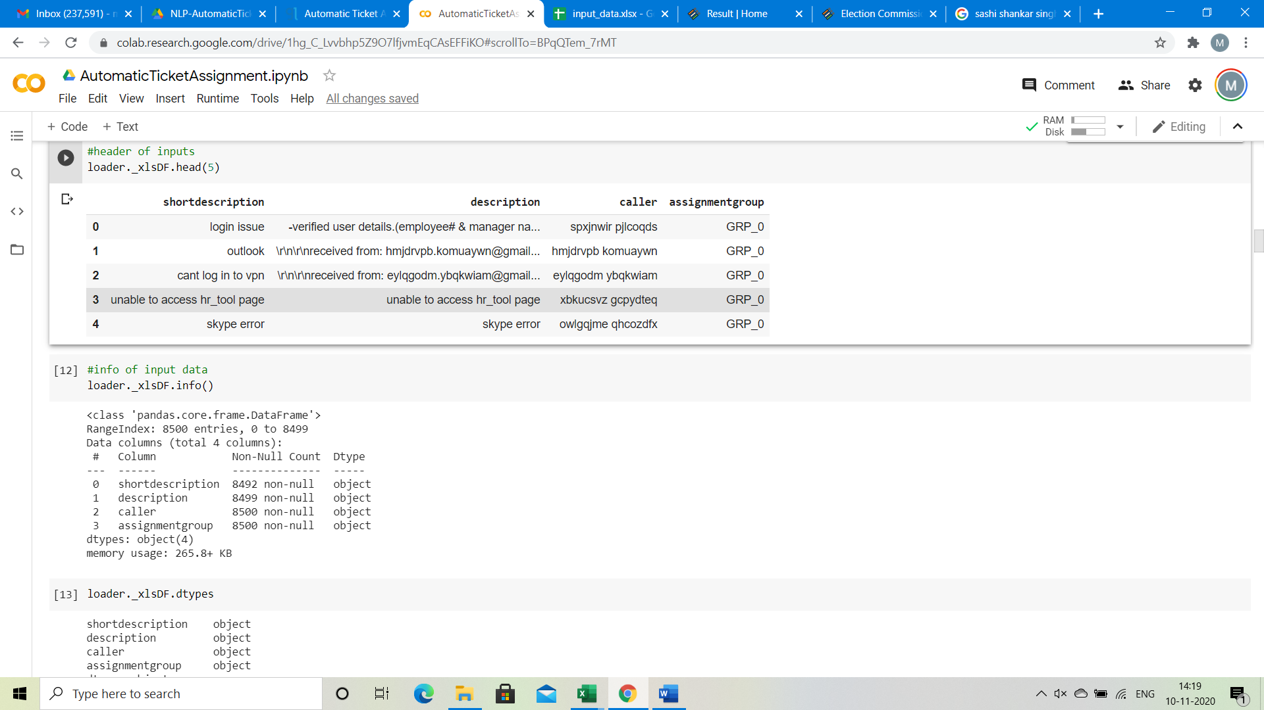
  - Four columns – Short Description, Description, Caller and Assignment group
  - 74 Assignment groups found - Target classes
  - Caller names in a random fashion (may not be useful for training data)
  - European non-English language also found in the data
  - Email/chat format in description
  - Symbols & other characters in the description
  - Hyperlinks, URLS & few image data found in the description
  - Blanks found either in the short description or description field
  - Few descriptions same as the short description
  - Few words were combined together
  - Spelling mistakes and typo errors are found

Observations from Target Class

The data contains 8500 entries, with some missing values in certain columns.
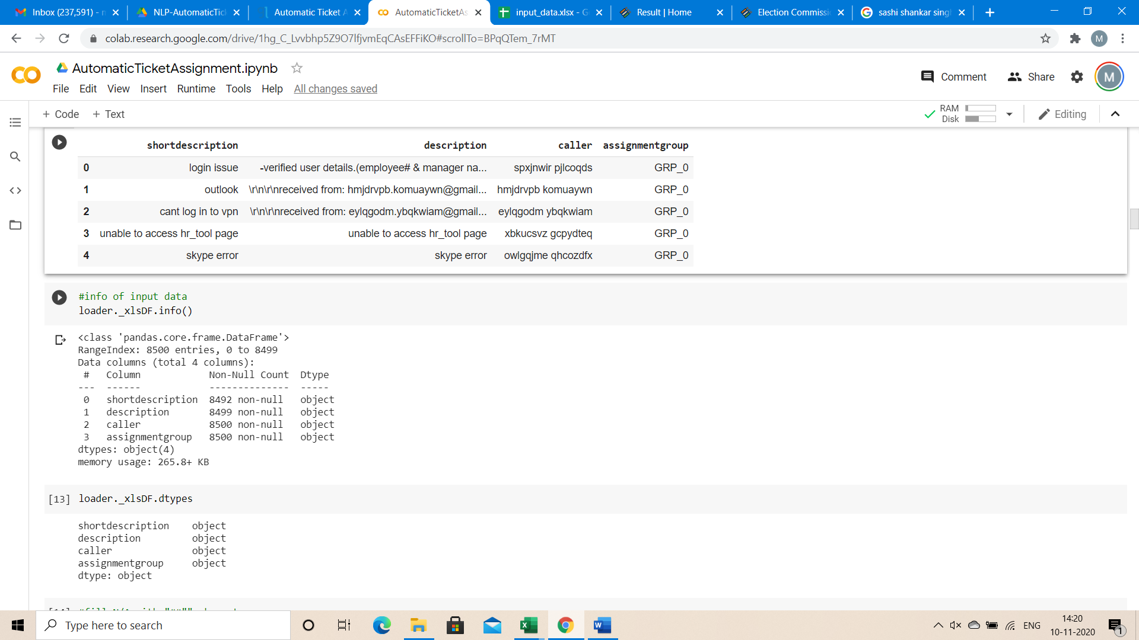
  - The Target class distribution is extremely skewed
  - A large no of entries for GRP_0 (amounting to 3976) which account for ~50% of the data
  - There are groups with 1 entry also. We could merge all groups with small entries to a group to reduce the imbalance in the target. This may reduce the imbalance to some extent.

Summary of the Approach to EDA and Pre-processing

Data Pre-processing
Below steps have been performed for initial pre-processing and clean-up of data:
  - Dropped the caller field as the data was not found to be useful for analysis
  - Replaced Null values in Short description & description with space
  - Merged Short Description & Description fields for analysis
  - Contraction words found in the merged Description are removed for ease of word modelling
  - Changed the case sensitivity of words to the common one
  - Removed Hashtags and kept the words, Hyperlinks, URLs, HTML tags & non-ASCII symbols from merged fields
  - Translating all languages (German) to English
  - Tokenization of merged data
  - Removal of Stop words
  - Lemmatization
  - Word Cloud created for all available 50 groups to have more information specific to Assignment groups
  - Attempted to do spell check
  - Created Plot to understand the distribution of words

Data Pre-processing – Addressing skew of target class
The target class is extremely skewed data. The target class were filtered for less than 10 entries and grouped together as misc_grp as there is not sufficient information with the groups individually, where there are less than 10 entries.

Distribution of Target class for all groups (after adding misc_grp)

To further address the imbalance in the target class, we have split the dataset as 2 groups
  - A dataset where we resample all the groups to size 660. Here note GRP0 would be down sampled& all other groups would be up sampled.
  - We could use 2 separate models. Here one model would be used to classify the GRP0 & a second model would be used to classify the other groups. The dataset from the 1st model contains GRP0 data & all the remaining data combined to a single group, say, ‘Others’. The dataset for the 2nd Model would contain all groups other than GRP0. The dataset here would be resampled again to address the target imbalance if any.
Distribution of Target class for Other groups

Data cleaning
Through the process of data cleaning we would want to clean up the unwanted information from initial observations. All words are converted to lowercase. The email headers and sender information is also removed. All the numbers, non-dictionary characters, newline characters, hashtag, HTML entities, hyperlinks, extra spaces and unreadable characters and any caller names included in the description column are removed. The clean_data function is applied to the description column and cleaned up data is generated for further analysis.

Word Distribution
A plot has been created to analyse the distribution of words in each ticket. It has been found that most of the descriptions of the problems raised by callers are short within 0-100 words. Few entries are a bit descriptive.
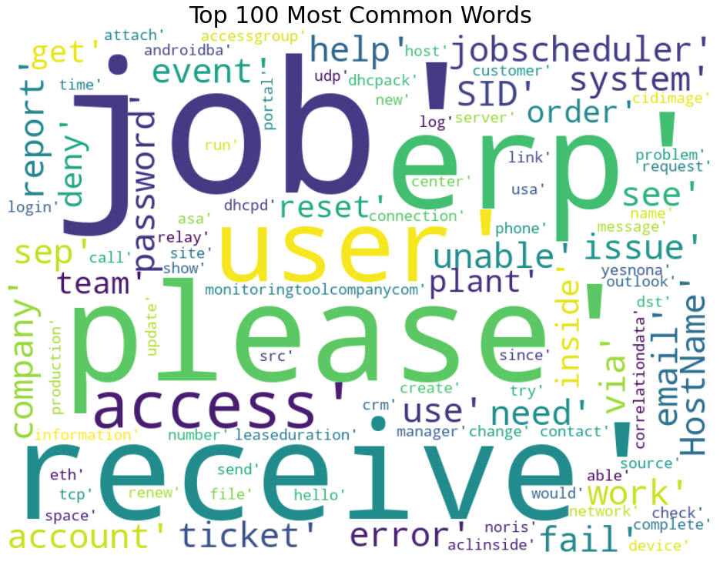

Lemmatization & Stop words removal
Stop words have been removed using nltk corpus modules.
Lemmatization is the process of grouping together the different inflected forms of a word so they can be analysed as a single item. Lemmatization is like Stemming but it brings context to the words. So, it links words with similar meanings to one word. Here we have preferred Lemmatization over Stemming because lemmatization does morphological analysis of the words.

Spell Check
We have used pySpellchecker to perform spell check on the data. But there were few technical words which were also corrected with this function. Eg. Hostage for hostname, sky for skype, wife for wifi, etc. So, a set of exceptional words have been loaded with such IT related technical words.
We found that performing spell check was a time-consuming process. Although spell check helped in reduction of vocabulary size, it did not help in model accuracy improvement. Hence,we decided against applying spell check as it did not provide any substantial improvement to the whole process.

Deciding Models and Model Building

Modelling

Traditional ML Models

Random Forest Classifier Model
Random forests is a supervised learning algorithm. It can be used both for classification and regression. It is also the most flexible and easy to use algorithm. It creates decision trees on randomly selected data samples, gets prediction from each tree and selects the best solution by means of voting. It also provides a good indicator of the feature importance.

Support Vector Machines (SVM) Model
A support vector machine (SVM) is a supervised machine learning model that uses classification algorithms for two-group classification problems. After giving an SVM model sets of labelled training data for each category, they’re able to categorize new text. This is a fast and dependable classification algorithm that performs very well with a limited amount of data.

Logistic Regression Model
Logistic regression is a supervised machine learning algorithm that is used for classification problem. The key feature of this model is that it uses a sigmoid or logit function for classification. It is generally the first port of call for assessing a diverse set of classification problems.

Observation from the results of the traditional models
From the predicted accuracies, we could see that the traditional models with the resampled augmented dataset is performing with test accuracy of ~21% - 28%. However, the NN LSTM model gives a better train accuracy of ~94%, while it gives a test accuracy of ~91%. We believe that the NN LSTM model is performing satisfactorily. However, post the interim submission to work on additional methodologies like Recommendation Systems, to assess their performance on the given problem.

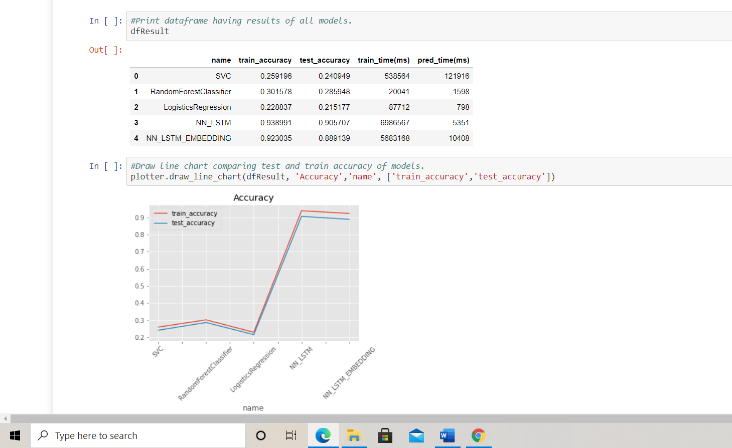

Model Clustering

Spacy module is used for lemmatization. PyLDAvis module is installed and applied for the plot to provide reasonable information on the data based on the topics. Bigram models are used to cluster relevant data together using GenSIM.
7 key topics have been extracted from the model. Relevancy of each topic from the provided data set is ~56% .
Copora dictionary has been created from the bigram words.

Analysis using WordCloud
WordCloud is a data visualization technique used for representing text data in which the size of each word indicates its frequency or importance. Significant textual data points can be highlighted using a word cloud. WordClouds have been generated with all available words & top 100 words. We have also inferred few observations over the target class – Assignment groups with word clouds for top 50 words from each group.
Word clouds for all words and top 100 words are as shown below.
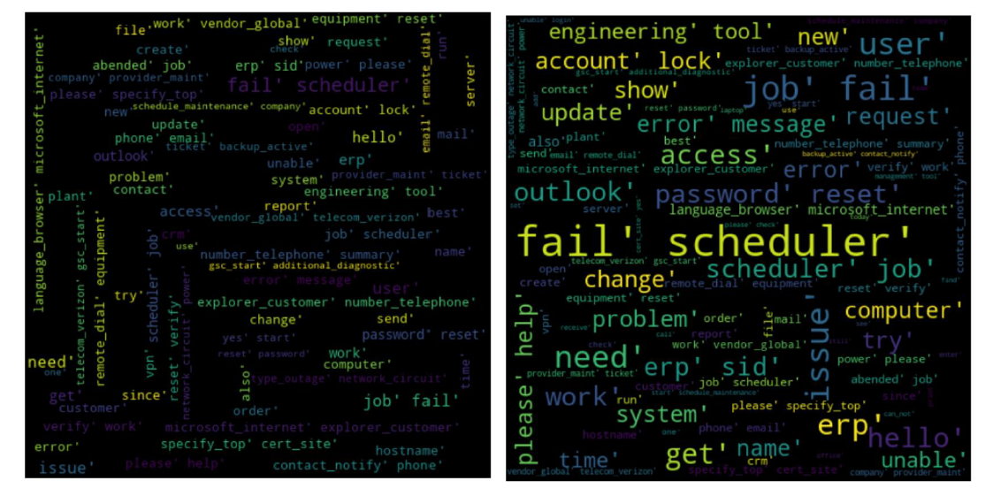
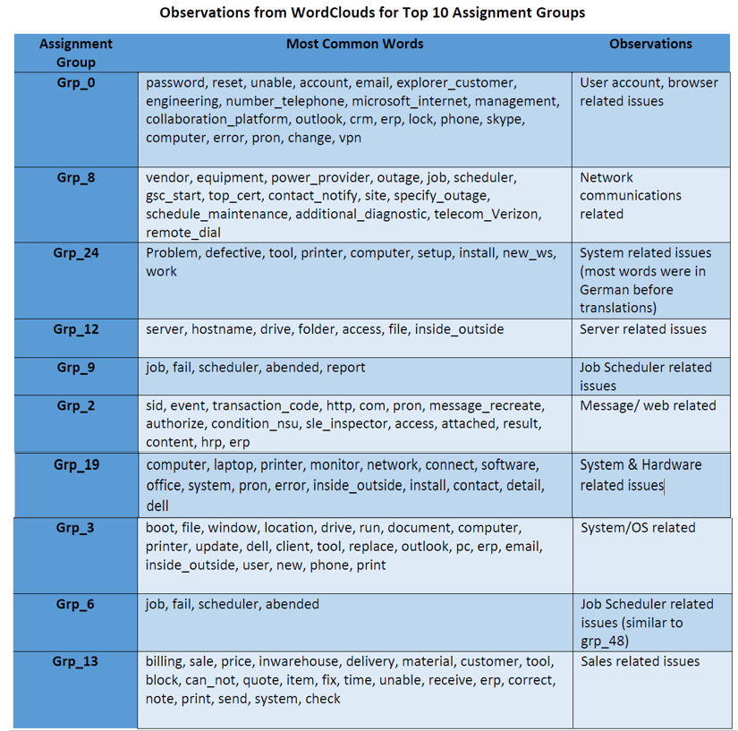

Model evaluation
Using the NLP models, from the predicted accuracies, we could see that the LSTM and LSTM Embedding models with the resampled augmented dataset is performing well with more than 90% accuracy. Although the differences in the accuracy are marginal, we have decided to go with the LSTM model, due to the better performance and comparable training time. The prediction time for the LSTM model is superior to the LSTM Embedding model.

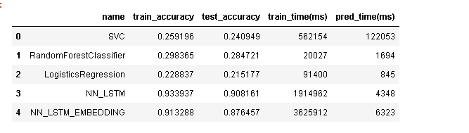
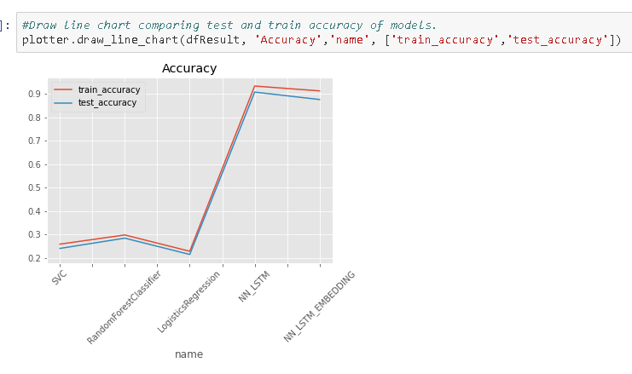
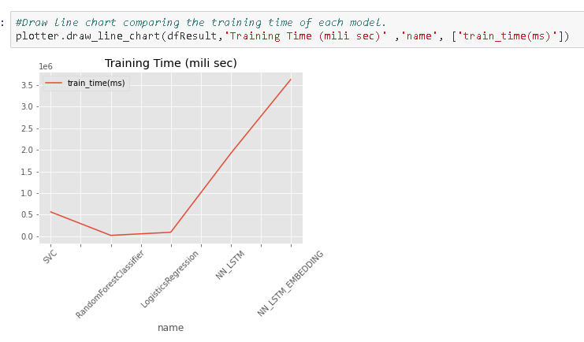
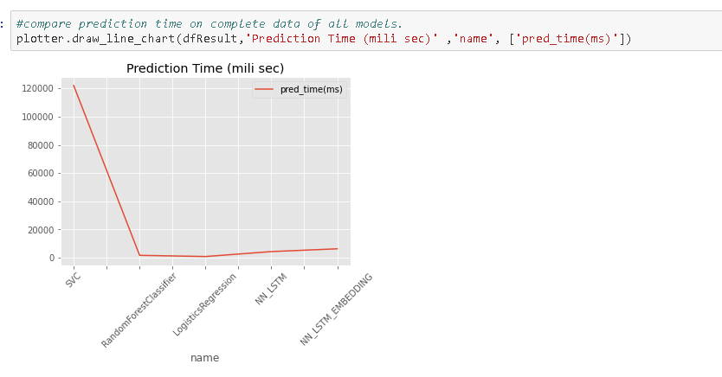

Comparison to benchmark
From the given problem description, we could see that the existing system is able to assign 75% of the tickets correctly.
So, our objective here is to build an AI-based classifier model to assign the tickets to right functional groups by analysing the given description with an accuracy of at least 85%.
From the prediction results we see that the LSTM model based on the resampled data is able to achieve an accuracy of ~91% which is above our benchmark.

How to improve your model performance?
We have assessed the best suited hyper- parameters for our model by using Random Search CV techniques. We intend to use these techniques more comprehensively in the subsequent part of the project. Further as detailed below if some of the limitations of the data can be addressed, we can obtain a model with a superior accuracy.

Implications
Although this model can classify the IT tickets with ~91% accuracy, to achieve better accuracy in the real world it would be good if the business can collect additional data around 300 records for each group.

Limitations
As part of Data pre-processing, we had grouped all assignment groups with less than 10 entries as one group (misc_grp) which had reduced the Target class from 74 to 50 groups. While applying this model in the real world there could be additional intervention required to classify the tickets if it has been classified as misc_grp by our model. Since the number of elements reported under misc_grpis less, we expect this intervention to be done less often.

Suggestions for future model improvement
We found the data was present in multiple languages and in various formats such as emails, chat, etc bringing in a lot of variability in the data to be analysed. The Business can improve the process of raising tickets via a common unified IT Ticket Service Portal which reduces the above-mentioned variability. By doing this, the model can perform better which can help businesses to identify the problem area for relevant clusters of topics.

